Lewis & Clark SHRM Chapter 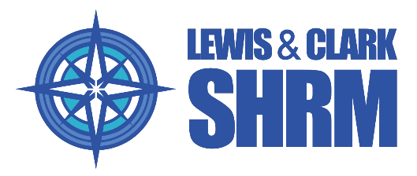

Business Partner & Sponsorship Application – 2026
Thank you for your interest in partnering with the Lewis & Clark SHRM Chapter. Our Business Partner & Sponsorship Program provides organizations with meaningful visibility and engagement opportunities with local HR professionals while supporting the continued success of our chapter.

Business Partnership Fee Please Circle - Gold or Silver
Gold Sponsor $500 (Annual – 2026) includes:
- Recognition of company name and logo on the Lewis & Clark SHRM website and membership emails
- Thank you from President at the opening of each meeting
- Company name and logo displayed at each Lewis & Clark SHRM membership meeting and event throughout 2026
- Opportunity to speak and present prior to one membership meeting during 2026
- Ability to distribute company information, brochures, and branded marketing materials at your selected presentation meeting
- Direct engagement with local HR professionals and organizational leaders
Silver Sponsor $250 (Annual – 2026) includes:
- Recognition of company name and logo on the Lewis & Clark SHRM website and membership emails
- Company name and logo displayed at each Lewis & Clark SHRM membership meeting and event throughout 2026
- Direct engagement with local HR professionals and organizational leaders

Organization Information
Company Name:

Company Size:
☐ 1–10 ☐ 11–50 ☐ 51–200 ☐ 201–500 ☐ 500+

Company Address:

Company Website:

Primary Contact Information
Main Contact Name:

Title:

Phone Number:

Email Address:

Primary Contact Bio
Please provide a brief professional bio for the main contact (education, experience, and role within the organization):

Organization Overview & Value to HR Professionals
Please describe your organization, the products or services you offer, and the value or benefits your organization provides to HR professionals:

Agreement
By submitting this application, the organization agrees to the $250 Business Partner & Sponsorship fee and participation guidelines established by the Lewis & Clark SHRM Chapter.

Submission & Payment Information
Please submit the completed application and request payment instructions by contacting:
Kameron Aaron Email: Kaaron@isolvedhcm.com Phone: 225.773.6678
Programs Chair, Lewis & Clark SHRM Chapter
Payment of $250 will be made directly to the Lewis & Clark SHRM Chapter following application approval.

